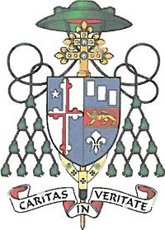
ARCHDIOCESE OF BALTIMORE
320 CATHEDRAL STREET • BALTIMORE, MARYLAND 21201 • 410-547-5437 • FAX: 410-547-8234
OFFICE OF THE ARCHBISHOP
December 2016
Dear Friend in Christ,
Twenty years ago, the Catholic Church initiated the Partners In Excellence (PIE) Scholarship Program to step-up the Church's response to a salient need within our community: improving educational options for children in Baltimore City. Working closely with Raymond "Chip" Mason, Mike Batza and Willard Hackerman, the Church sought to remove a formidable obstacle preventing families from choosing a Catholic education for their children by offering tuition assistance scholarships through the PIE program.
Since that time, a common trait that all of our Partners have shared is a firm belief in the transformative power of education to lift the aspirations of young people who struggle to see a future for themselves. Like so many Catholic school graduates who have gone before them, our PIE Scholars benefit from an academically excellent, values-based education, which draws forth the God-given talents within them. The track record of these students has been remarkable and the legacy of PIE is the lives and achievements of our graduates and their contributions to their families, communities, and workplaces.
I deeply appreciate your willingness to learn more about this important initiative, and it is my hope that you will be able to join us as a Partner In Excellence by sponsoring one or more students. In doing so, you would be giving great hope for the future to another student and his or her family.
With gratitude for your consideration, I am
Faithfully in Christ,

+>/.ŽL.Z
Most Reverend William E. Lori
Archbishop of Baltimore

